|  |
| --- |
| AWS  Serverless |

Abstract

Deployment of AWS Lambda functions is trivial when using the Serverless Framework.

With the Serverless Framework, you create Lambda functions using your familiar tools, on your local machine, then deploy to AWS in seconds.

This keeps your function’s code and configuration together, in the same Git repo.

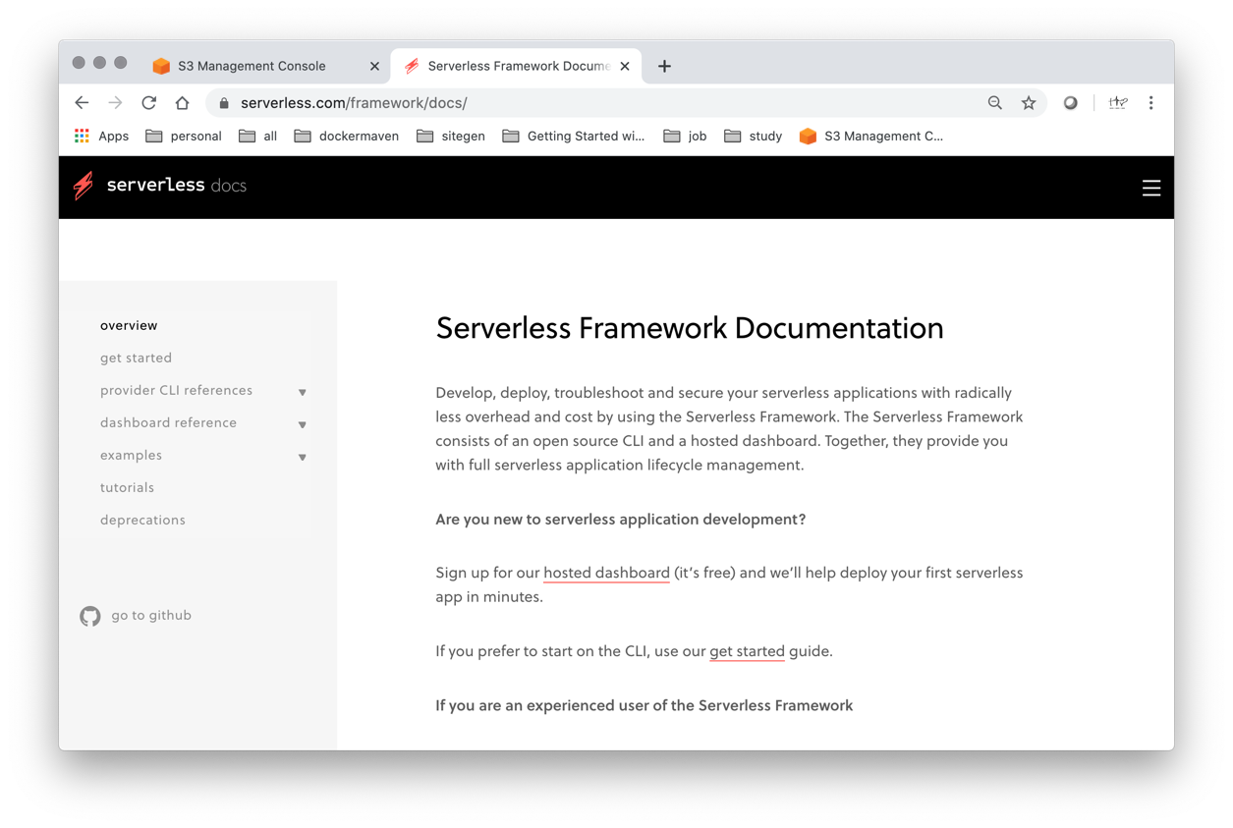



Project Structure and Design

Looking at the POM, you’ll see that there is no spring, nor spring-boot artifacts. In fact, Maven’s shade Plugin is being leveraged to make the lambda/serverless/callback JAR an executable unit.

Minimalistic.

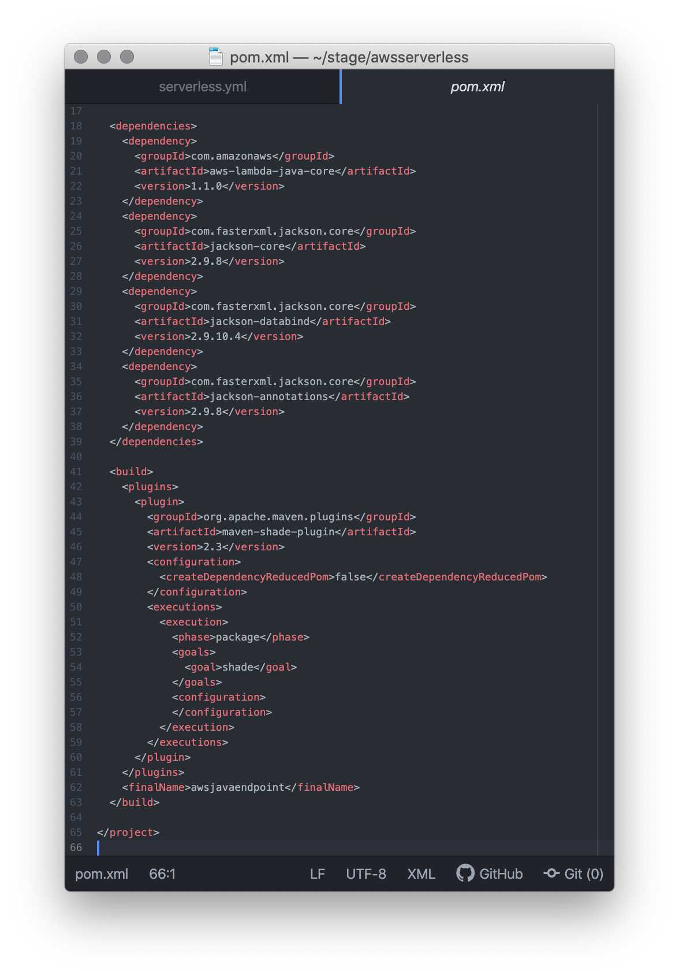

ßelow, the du -h filter/utility shows that the size of development JAR is three orders of magnitude smaller that the production version.

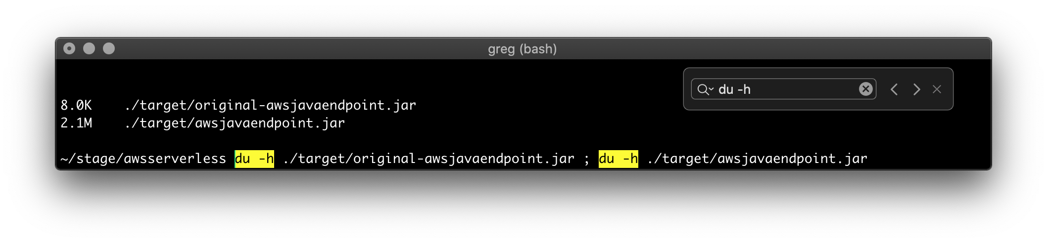



The requisite serverless.yaml file is located outside of the project root, likely as a security measure. This means that the application’s implementation is orthogonal to its configuration.

Since the requisite serverless.yaml file is located outside of the project root, it can be changed any time after compilation; however, it is imperative that it is correct before deployment.

For example, the Serverless platform ships with a generic package mapping in the serverless.yaml file, and this mapping must point to the Maven’s shade executable JAR file – see lines 9-10 below.

Likewise, the value of the service mapping on line 1 must match (by convention) the name of the executable JAR file – less the file extension – as it appears on line 10, below.

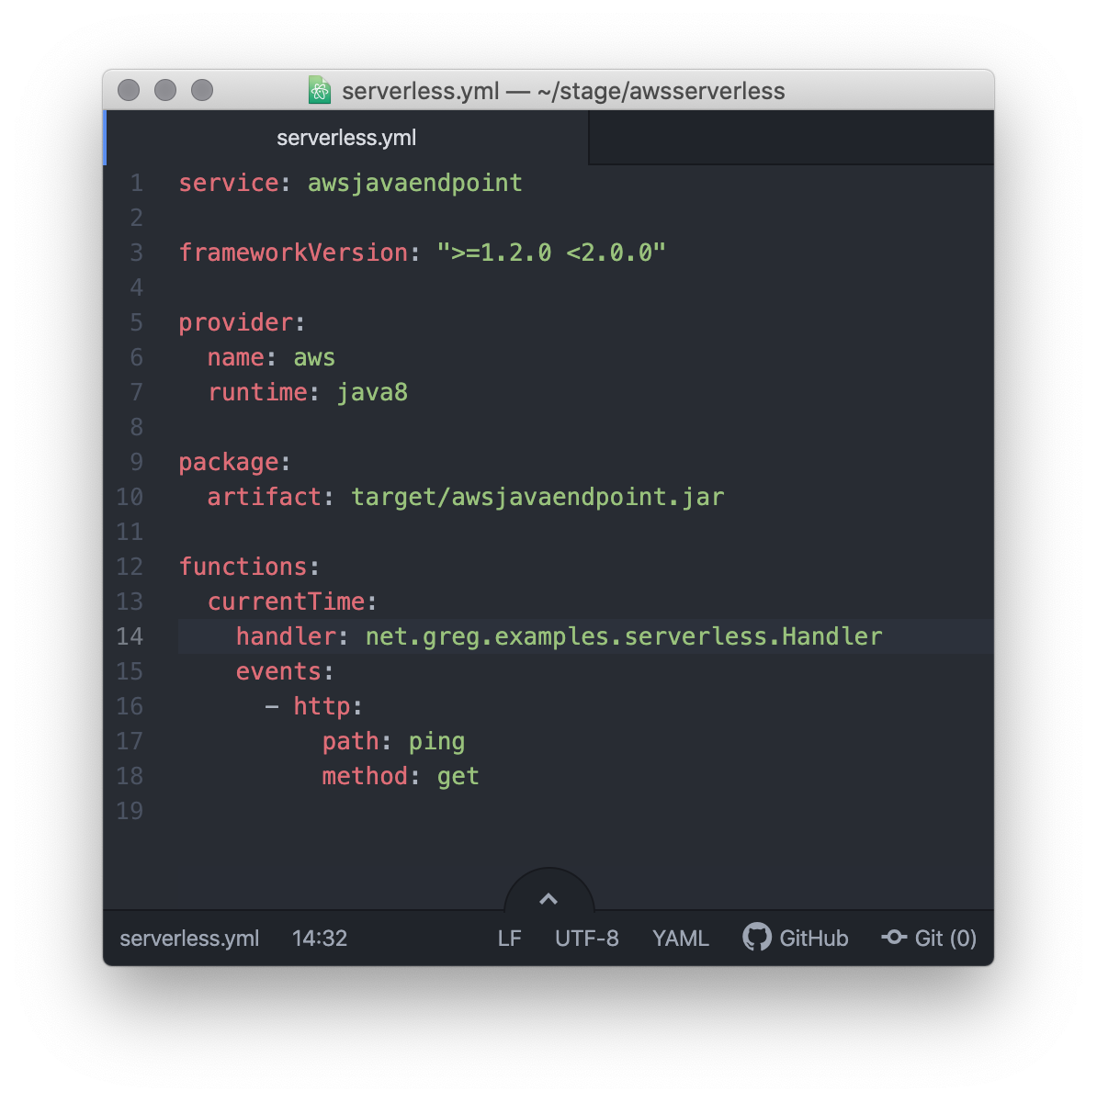



Initially, the meta-directory – dot-serverless [ .serverless ] – doesn’t exist. Once an AWS deployment occurs, the .serverless directory is created, and AWS CloudFormation deployment metadata is generated and deposited in JSON files within the .serverless directory.

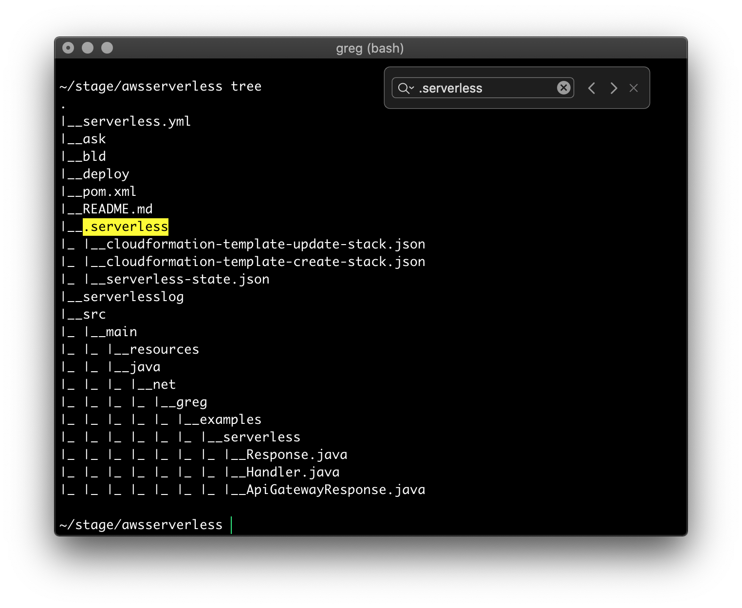



Deployment/Redeployment

After compiling into a JAR file, the three lambda/callback compilation units, use the Serverless App to deploy the JAR file to AWS.

There is one canonical Serverless command – serverless deploy – that I have installed into a ßash script (incase other lifecycle commands need to be added):

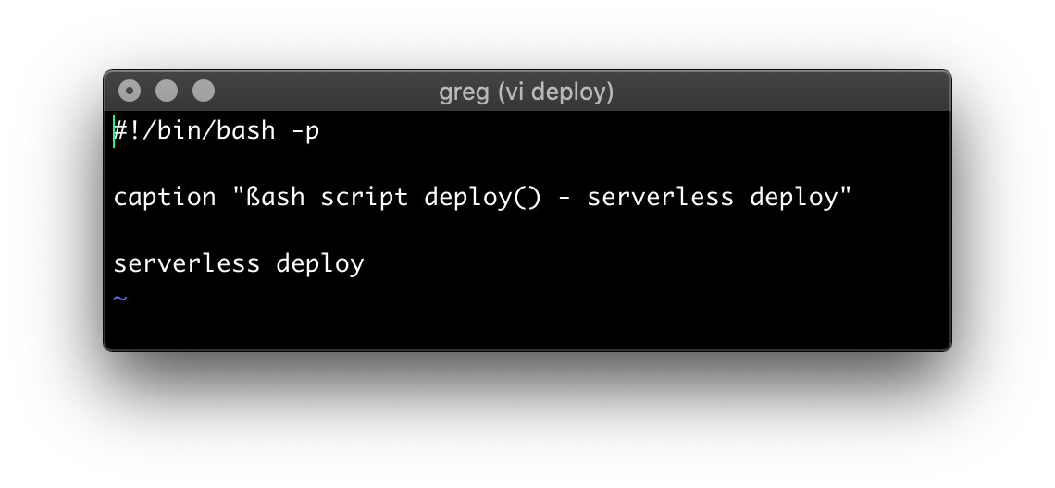

continues

Depending upon whether you are deploying a given service to the AWS S3 for the first time, you will see one extra line of at the bottom of the readout upon deploy:

Removing old service artifacts from S3 ...

In each case, you will see that a hashed URI that is the published Endpoint is sent back as part of the deployment readout.

When a substantive changes occurs at the binary level of the deployed of the lambda/callback, the hashed token (dlkx1j3ofe) portion of the (machine generated) Endpoint’s URI changes, too.

<https://dlkx1j3ofe.execute-api.us-east-1.amazonaws.com/dev/ping>

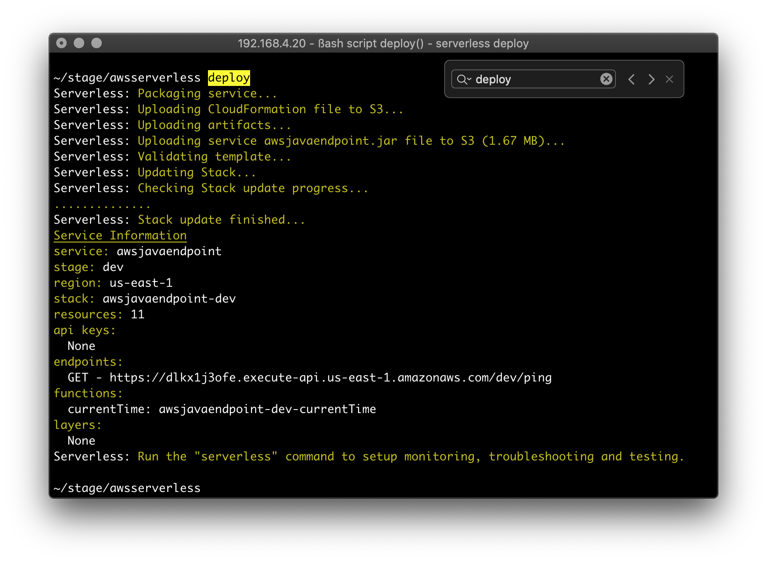



Deployment/Redeployment, Verification via AWS Console

After deploying a CloudFormation to AWS, you can look at the S3 service in the AWS Console. For this example project, navigate using this link:

[https://s3.console.aws.amazon.com/s3/home?region=us-east-2#](https://s3.console.aws.amazon.com/s3/home?region=us-east-2)

continues

Two screen shots of the AWS Console showing the deployed CloudFormation follow.

First, the current version of the console and then the prototype version). The screen shots both show the same information.

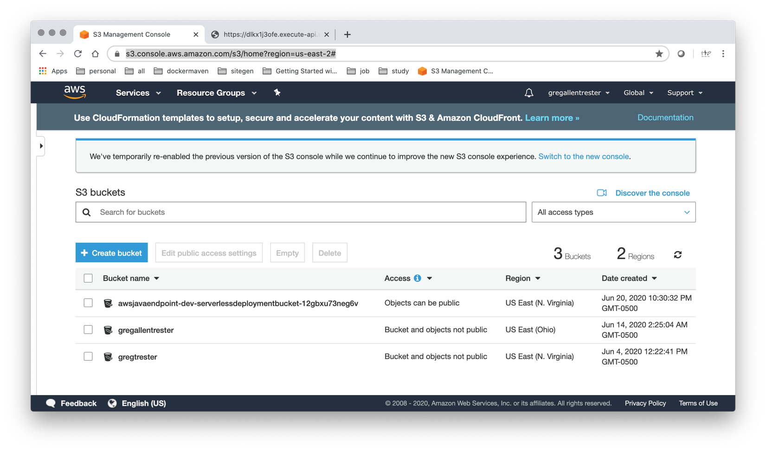

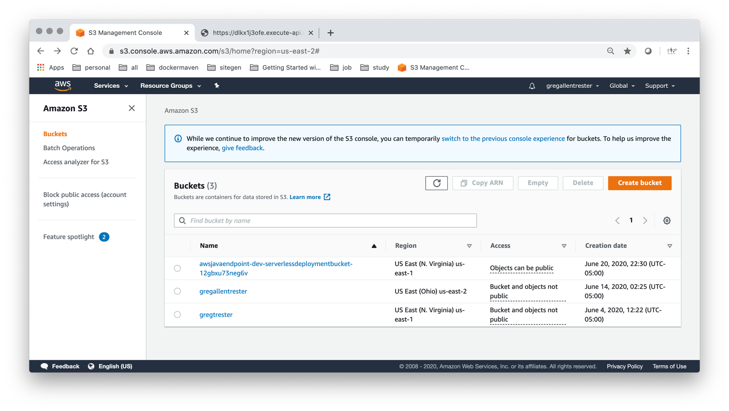



Example of Operation

To hit the newly minted endpoint, use any User-Agent to invoke the endpoint (to act as the originator of a call site).

Four ways have been suggested – I left out Postman, since it seems, it is slowly being supplanted by Newman.

cURL

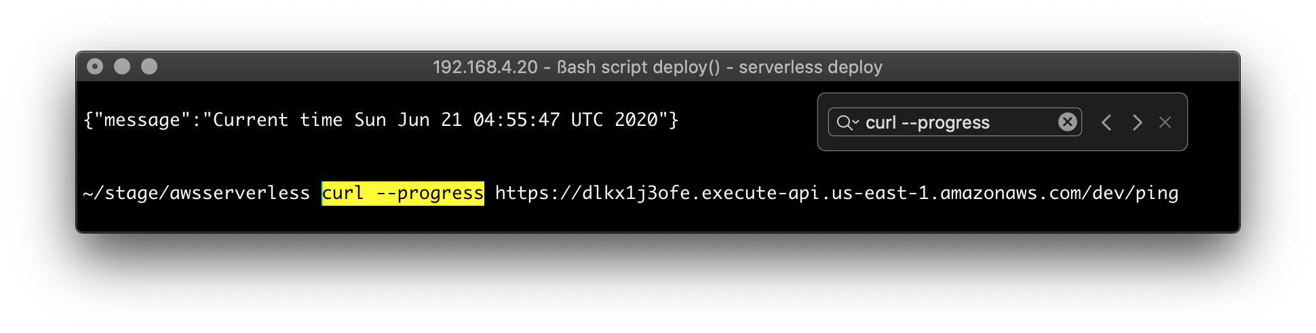

ßrowser

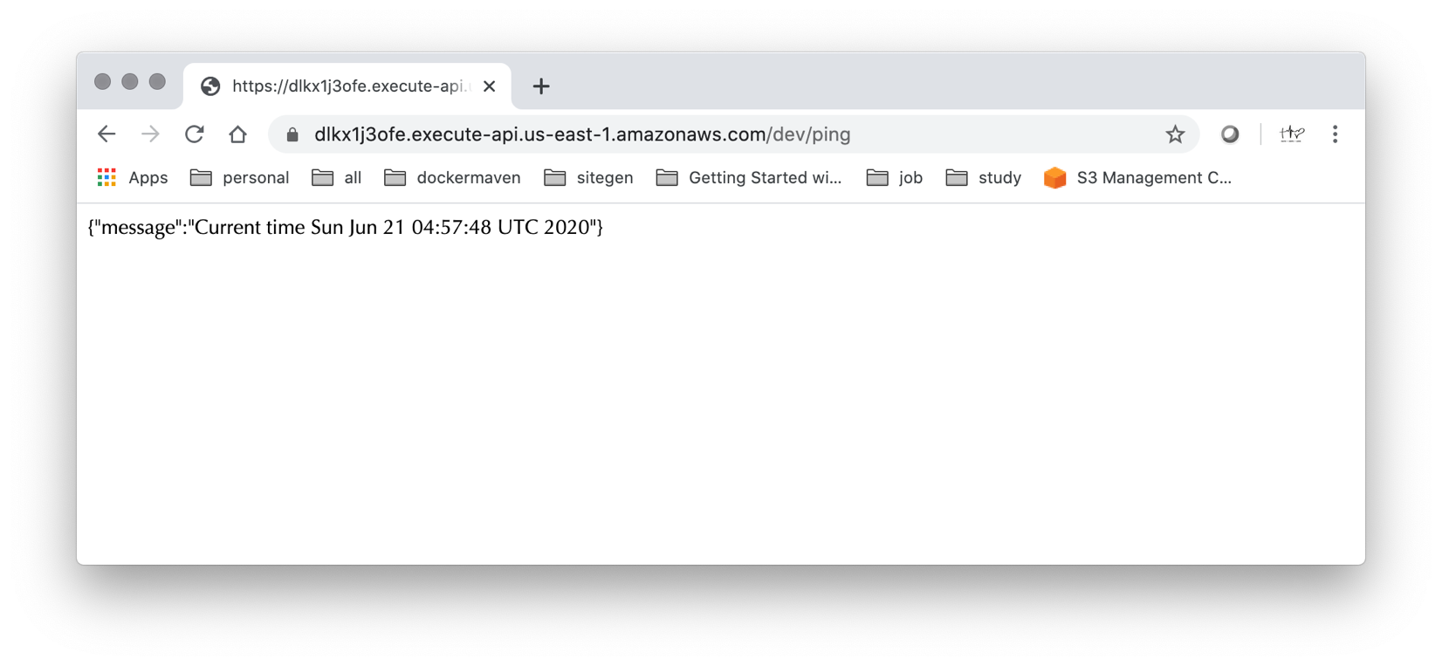

CLI – lambda/callback

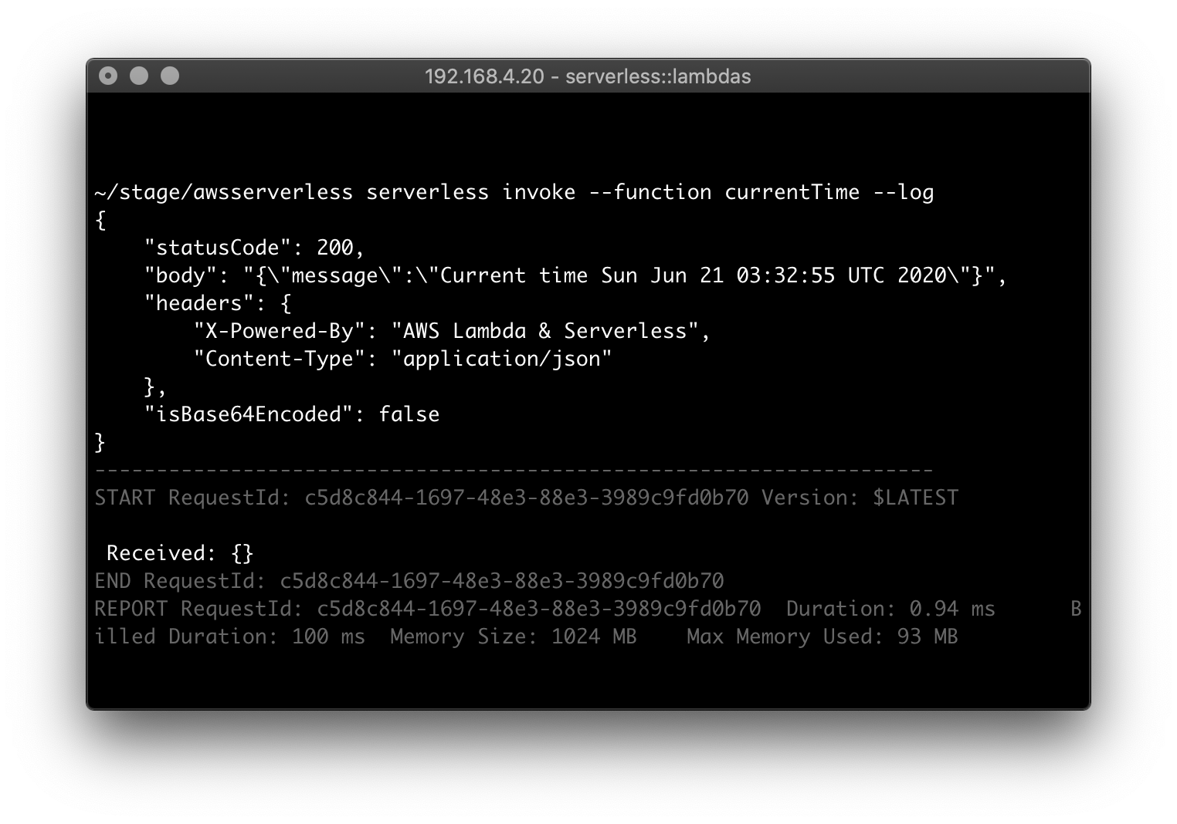

serverlesslog == serverless invoke --function currentTime –log



Checking the logs

Scripted CLI call.

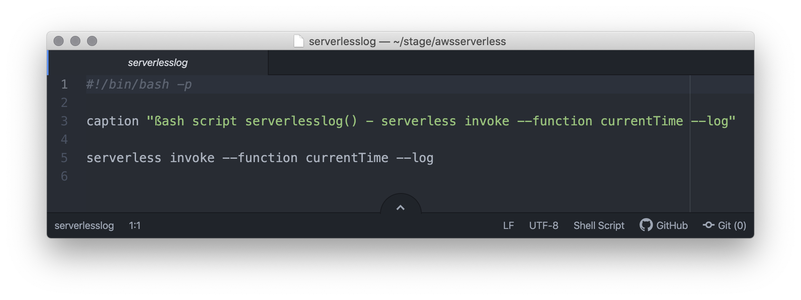

serverless invoke --function currentTime --log

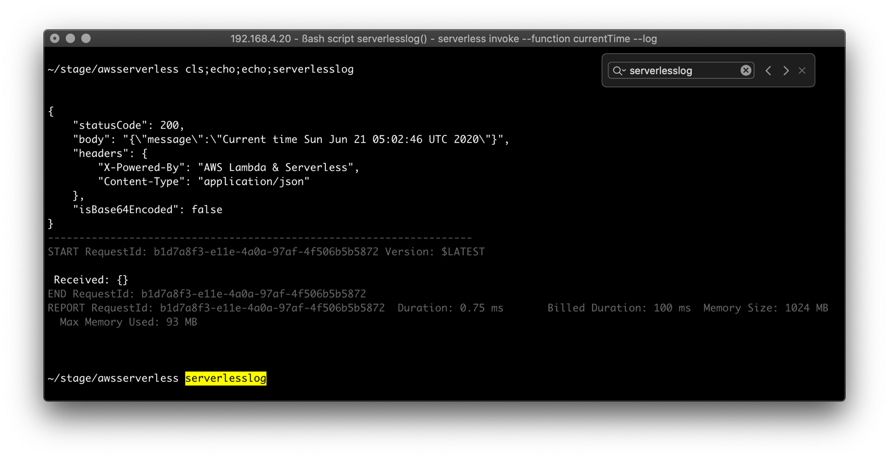



Three Compilation Units

1. Response.java

A POJO, the server’s message.

2. Handler.java

Implements 2 Interfaces:

a. *RequestHandler<Map<String,Object>*

b. *ApiGatewayResponse*

Within its overridden handleRequest() method, leverages calls to ApiGatewayResponse builder methods (uses Response instance) to craft a server response body (message).

3. ApiGatewayResponse.java

Creates a Base64Encoded message on behalf of the Handler class. By leveraging the ßuilder Design Pattern and Jackson’s JSON-2-Object mapper, ApiGatewayResponse creates a payload suited to an AWS lambda response.

continues

Response.java

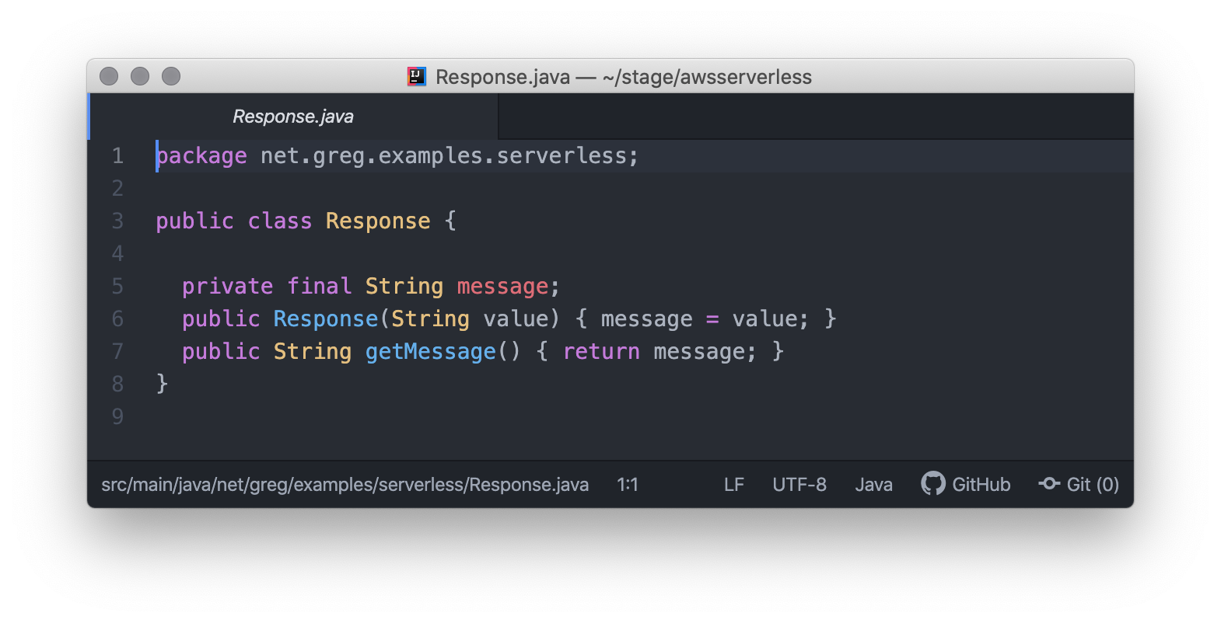



Handler.java

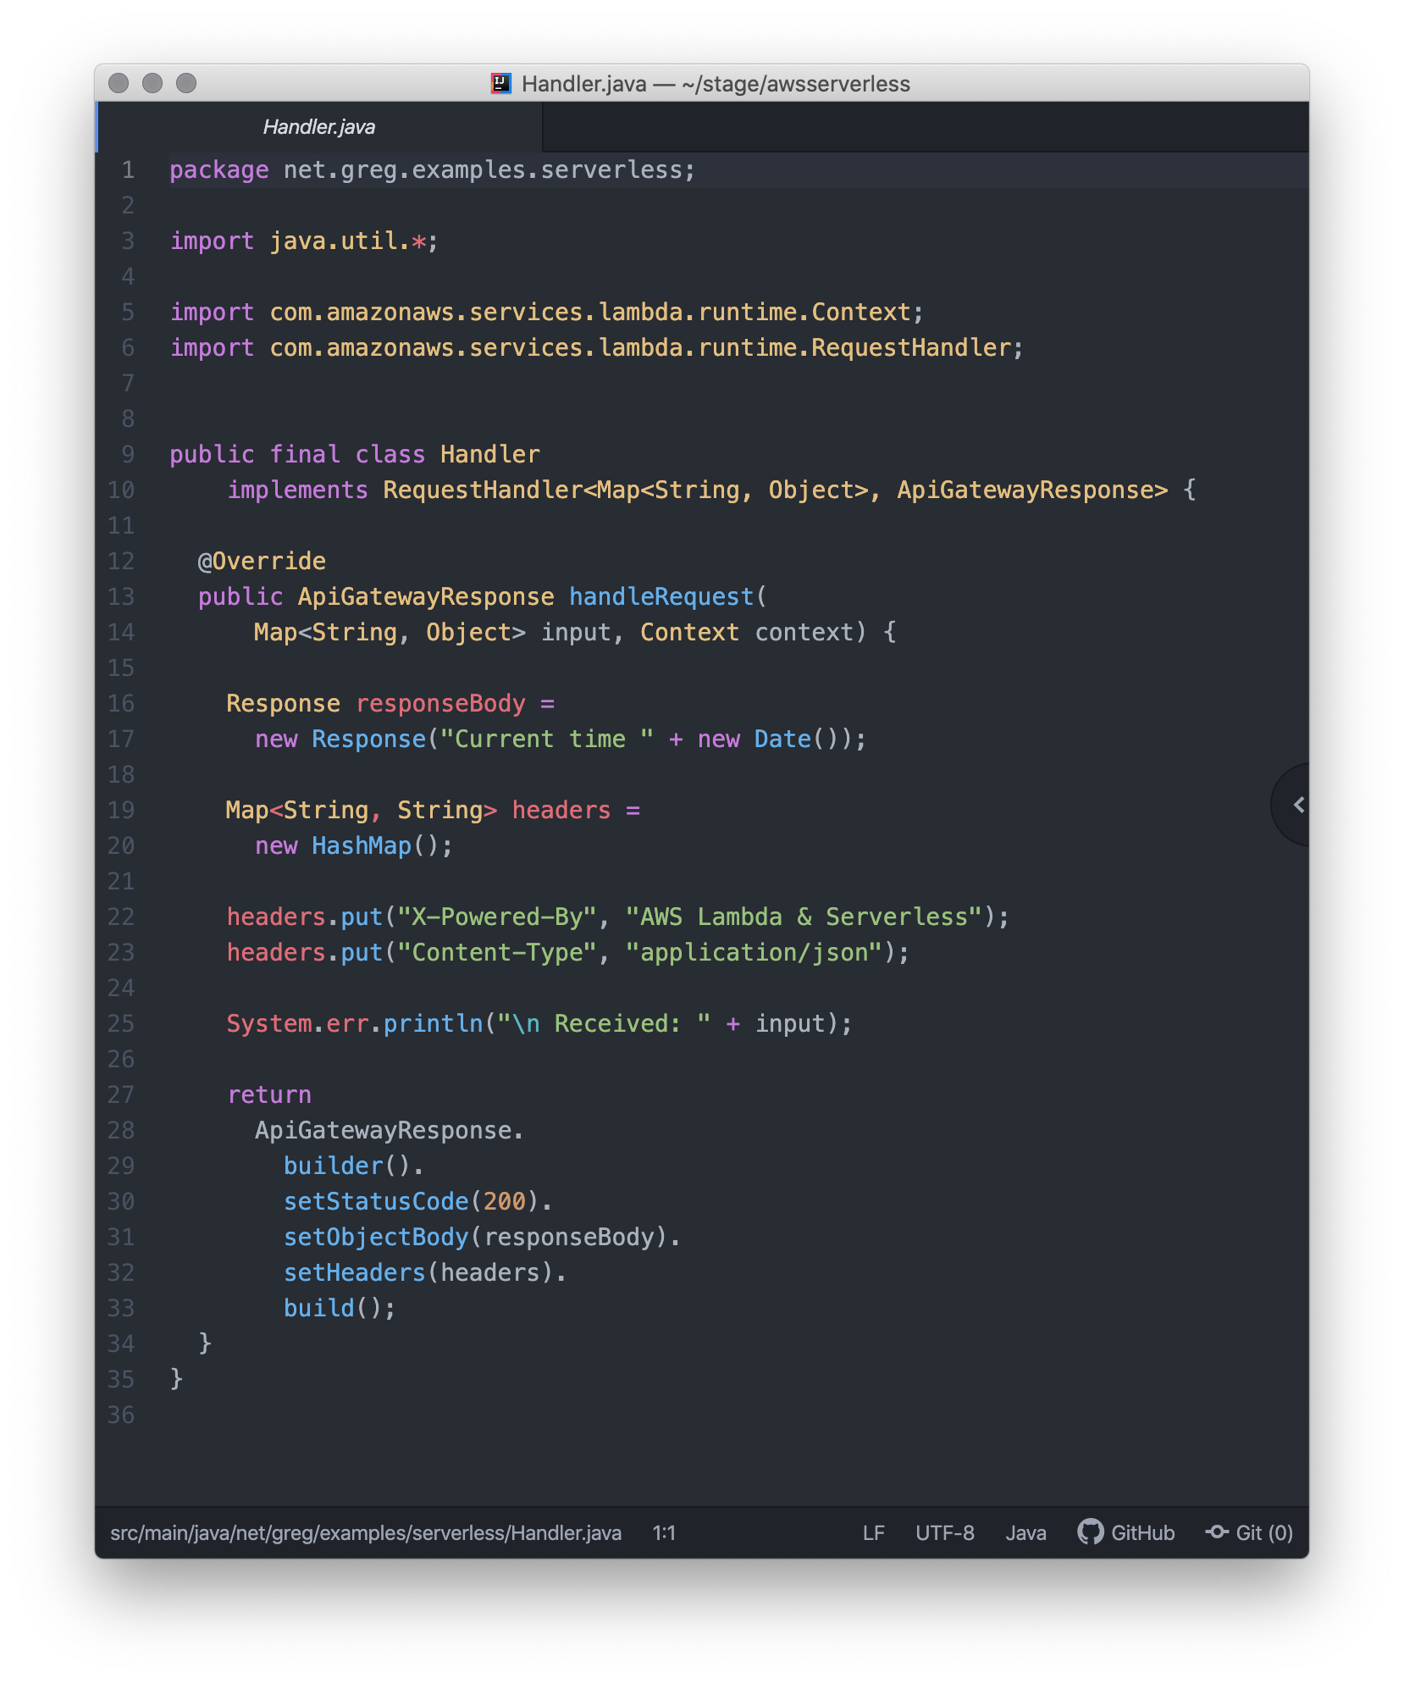



ApiGatewayResponse.java (4 shots)

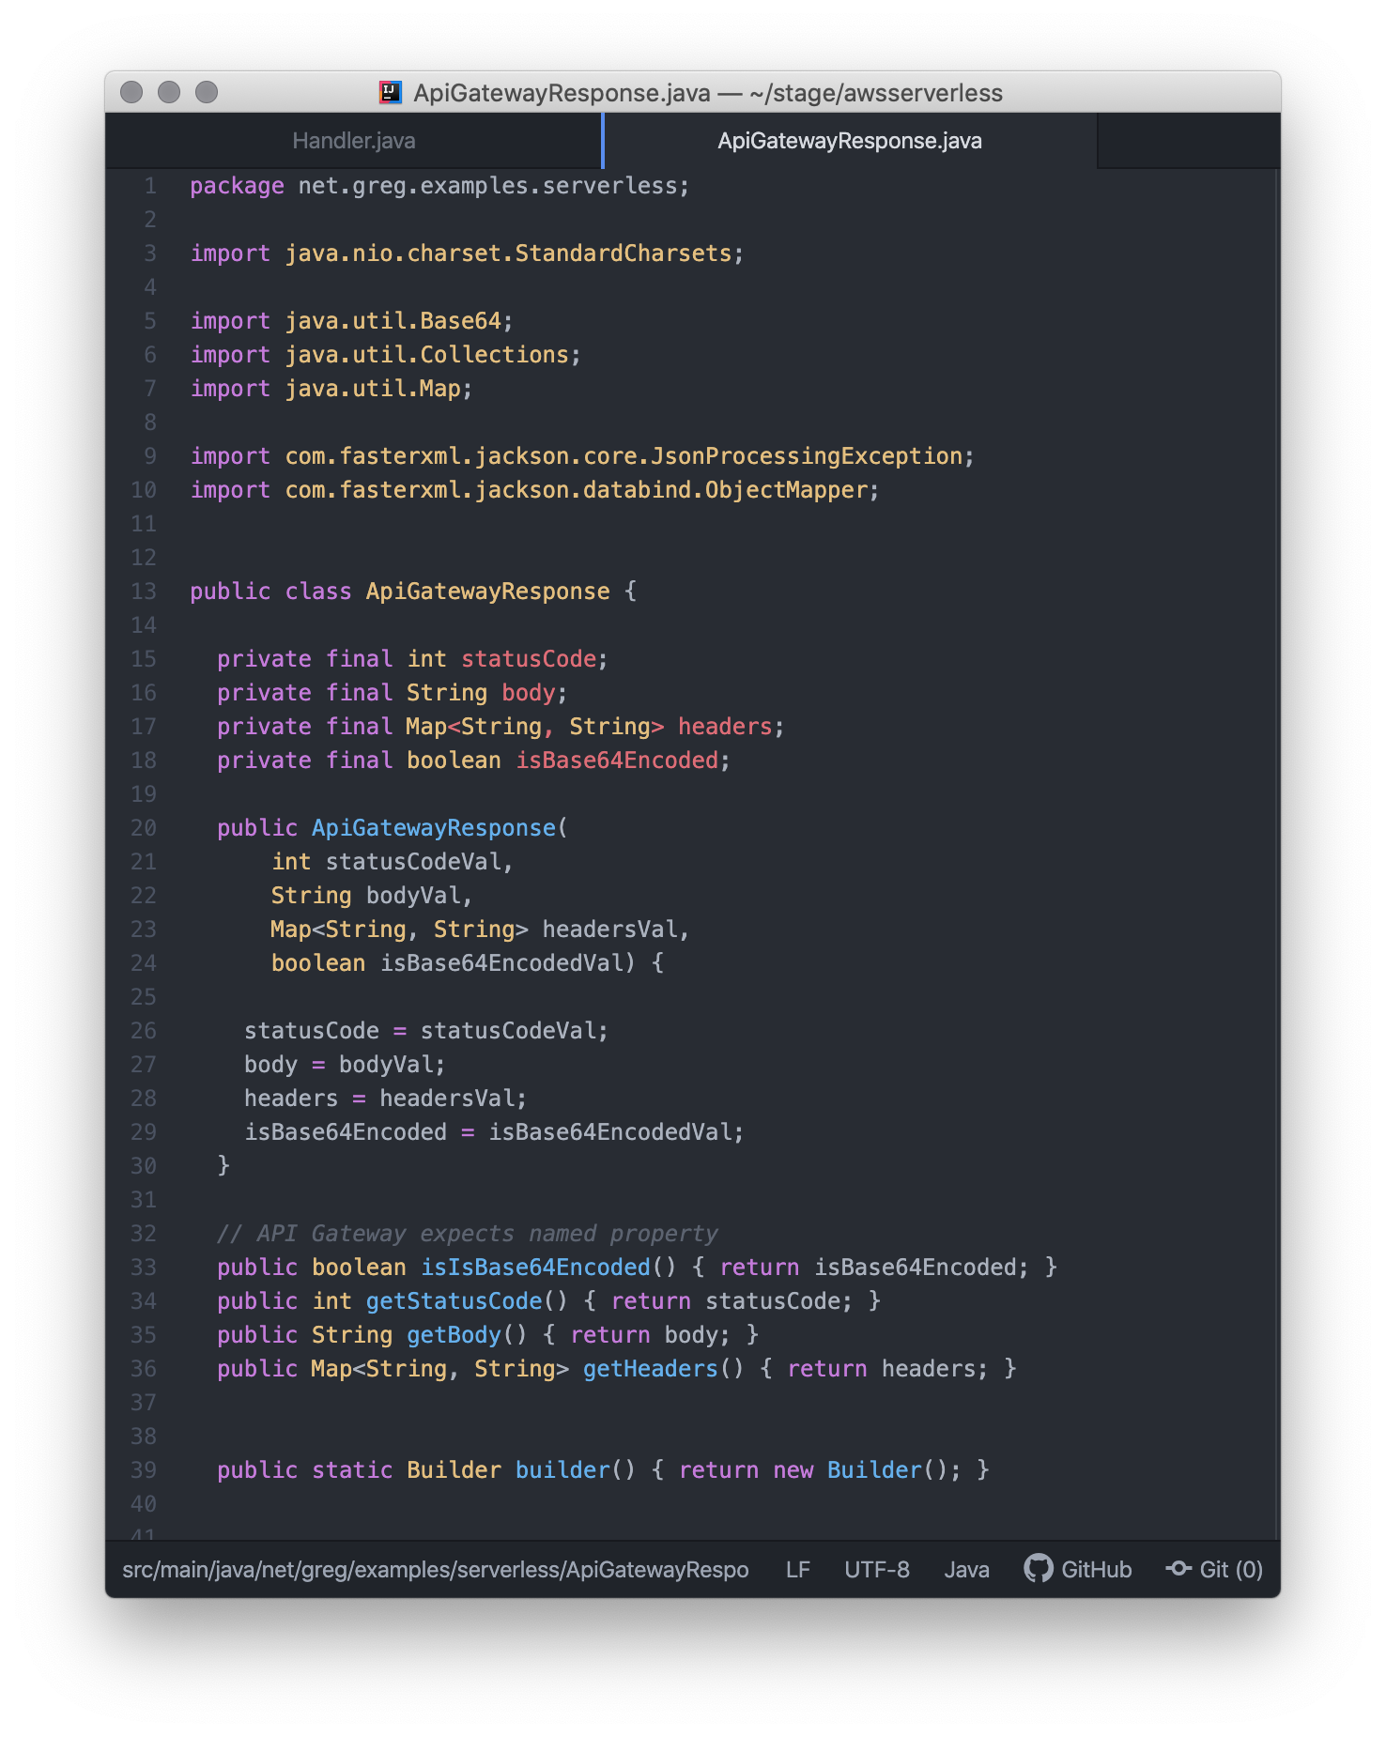

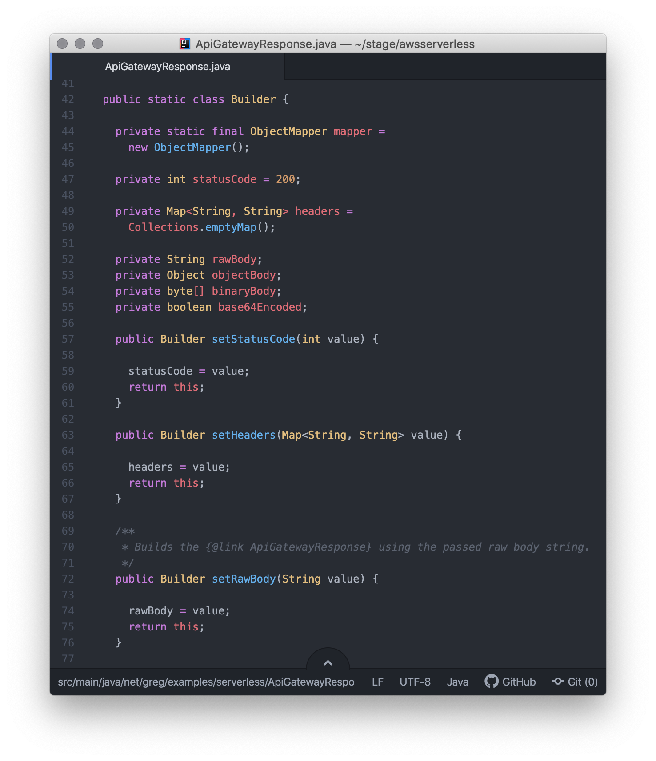

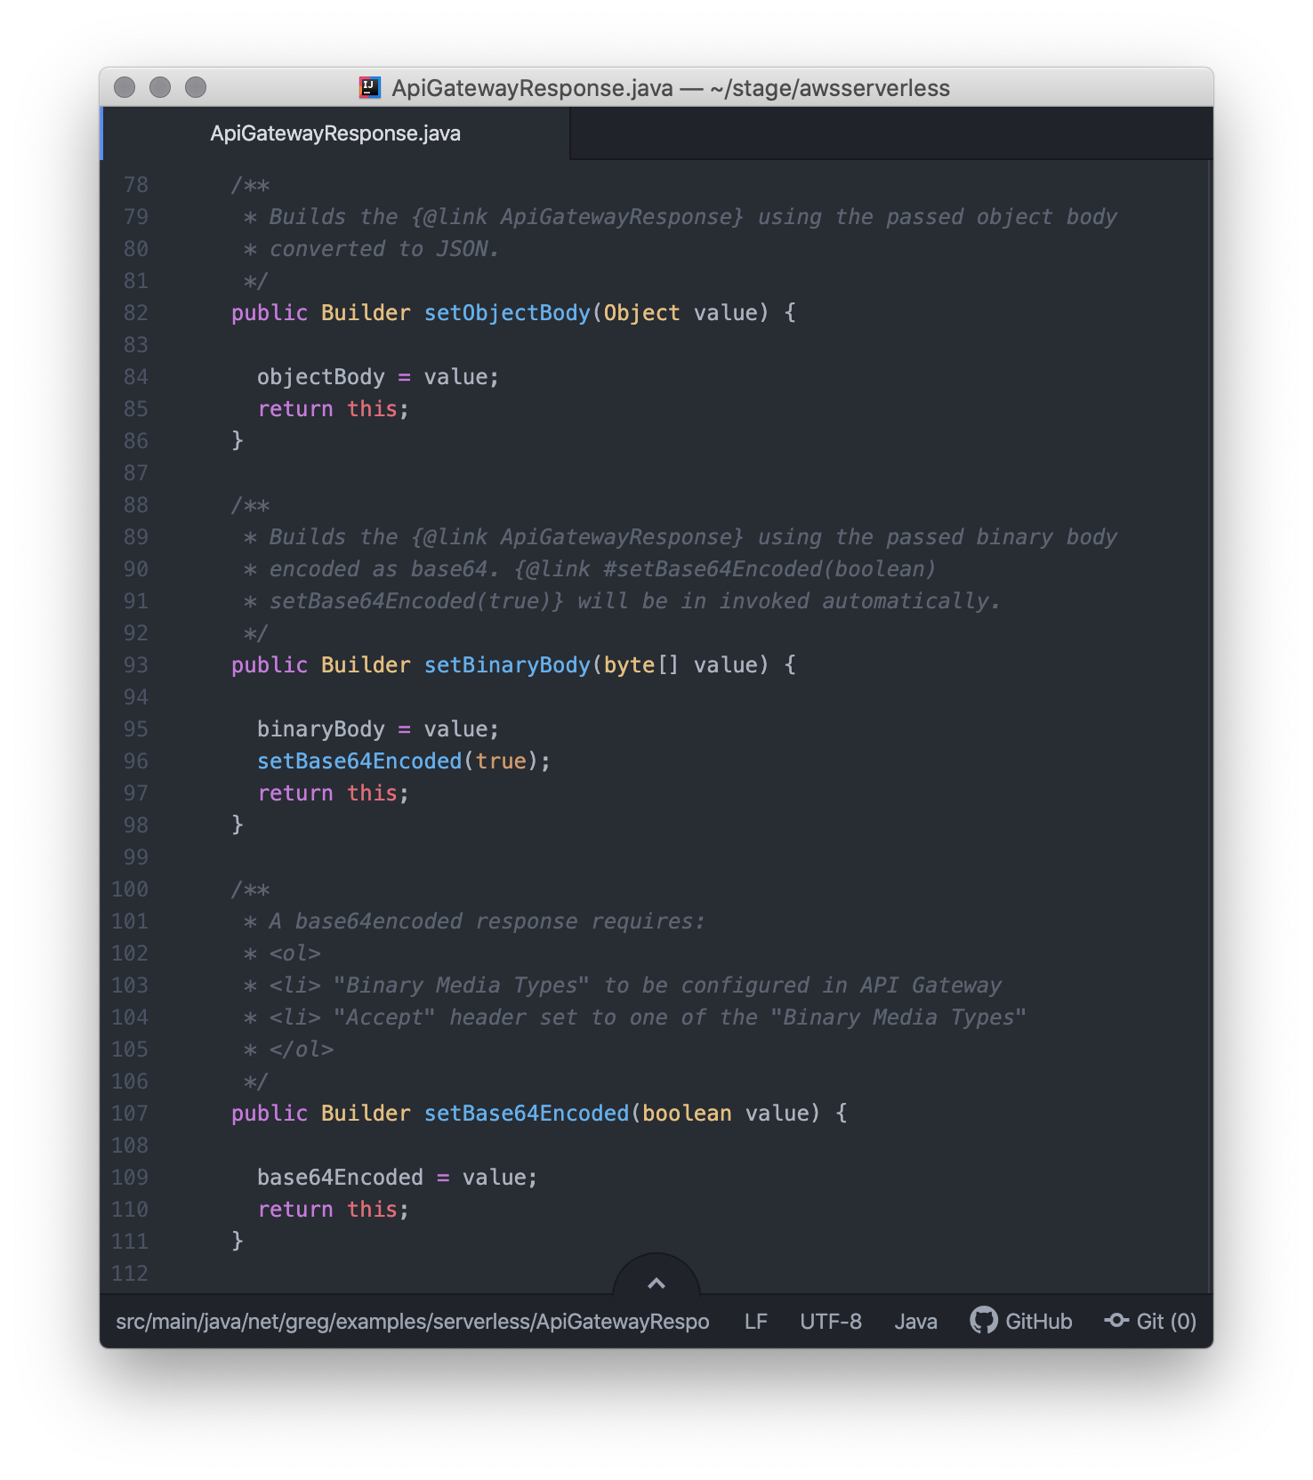



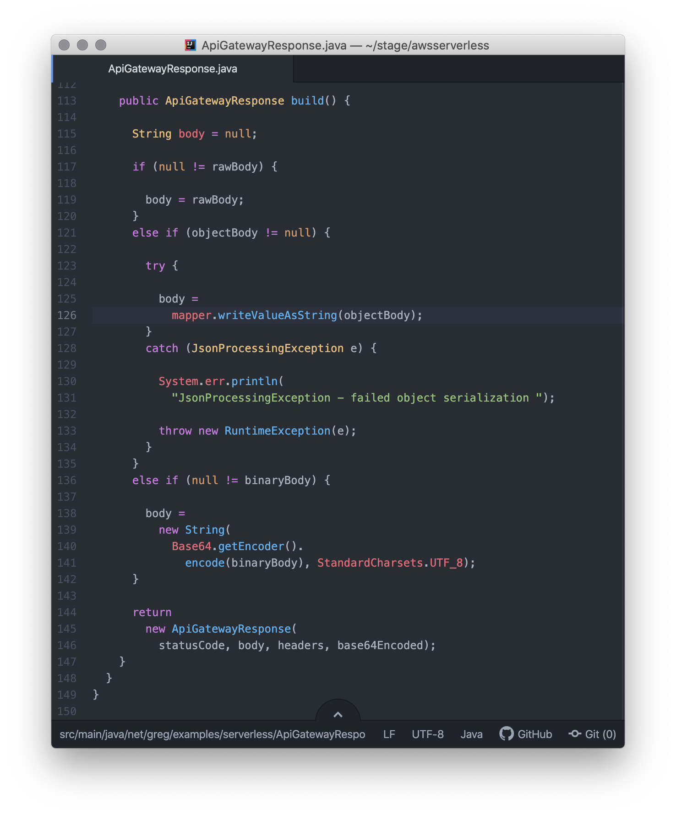

Screen shots of the README.md file

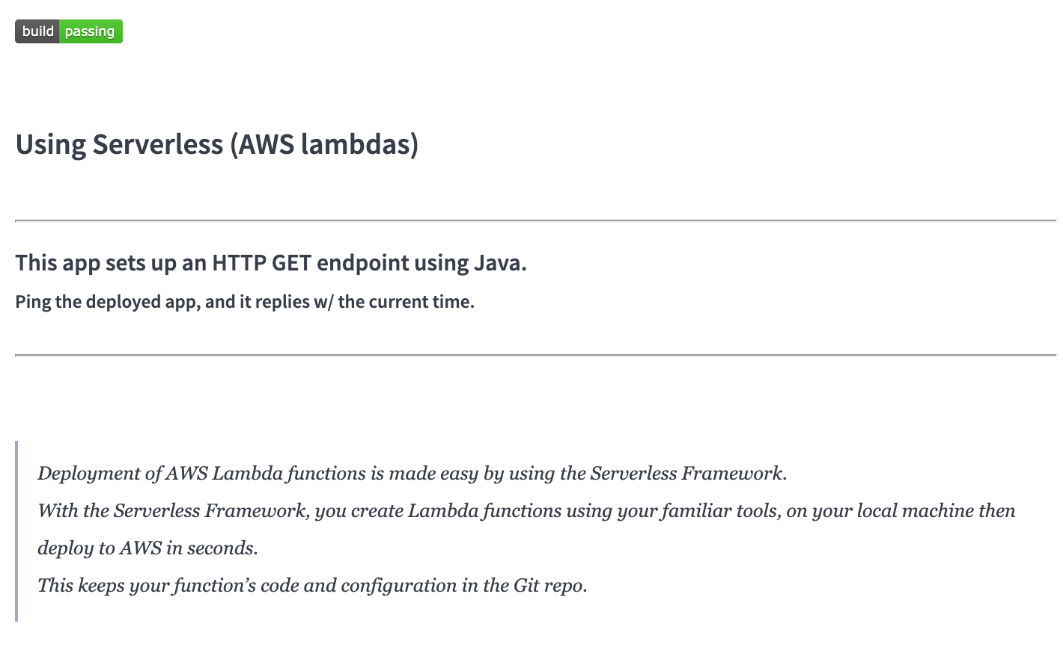

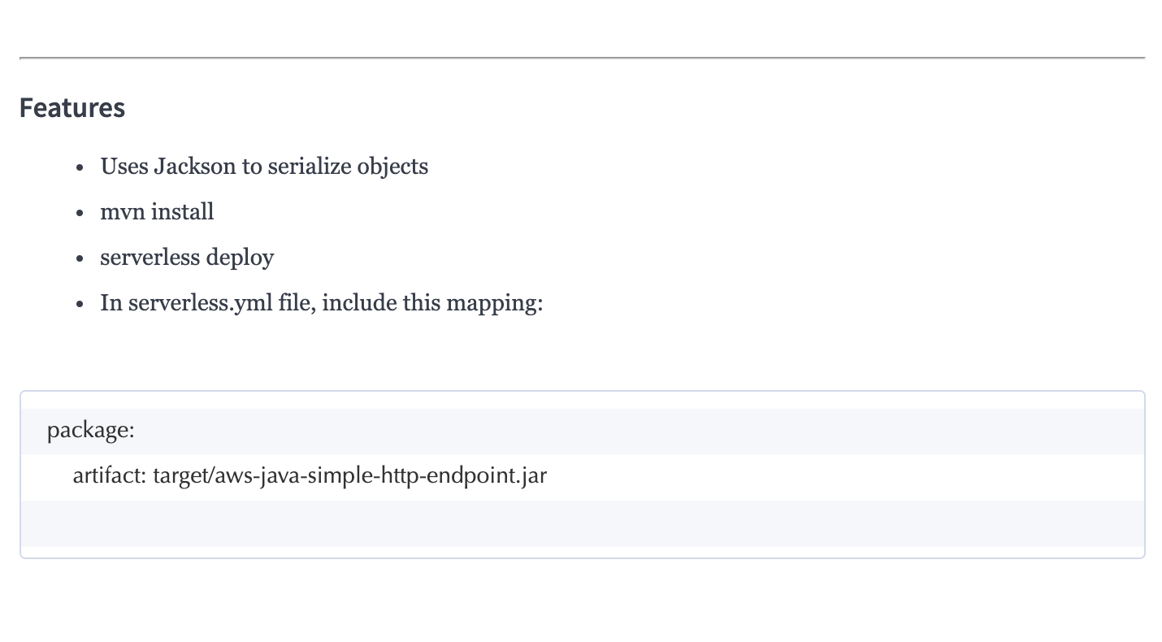

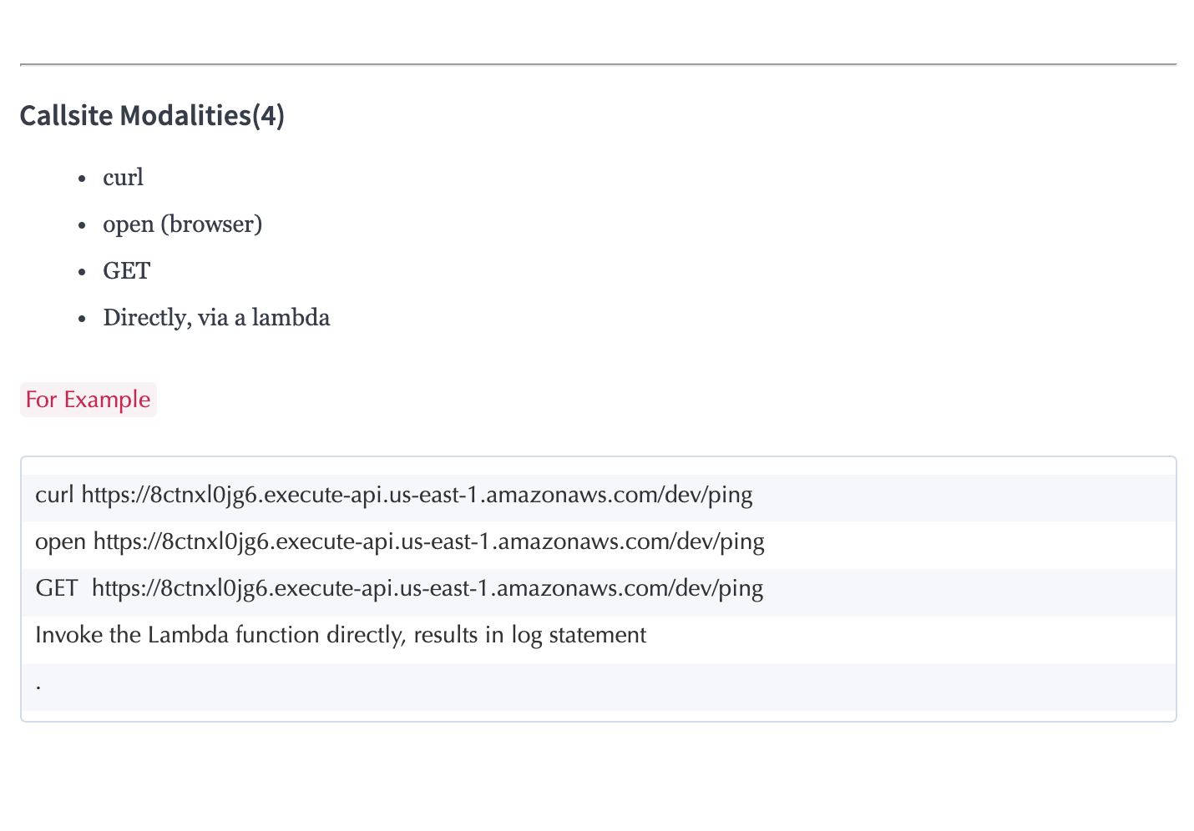

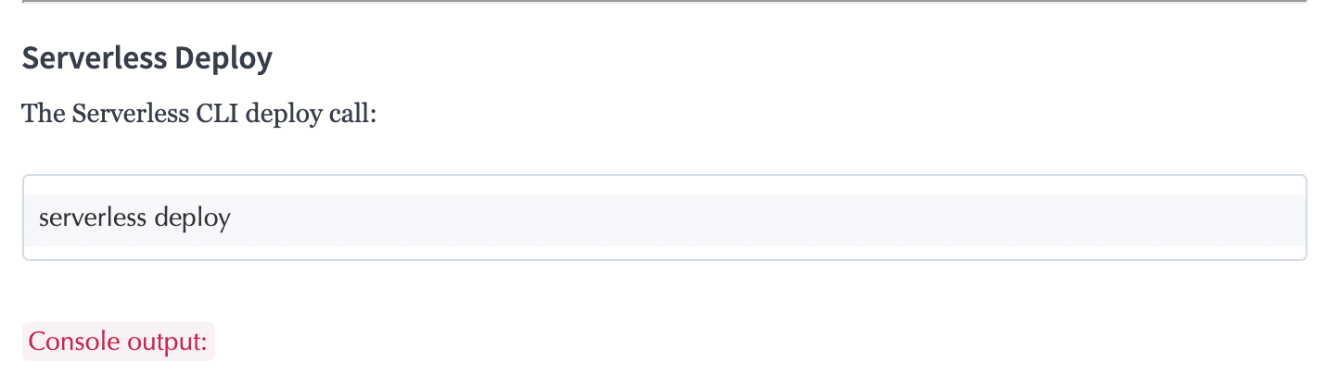

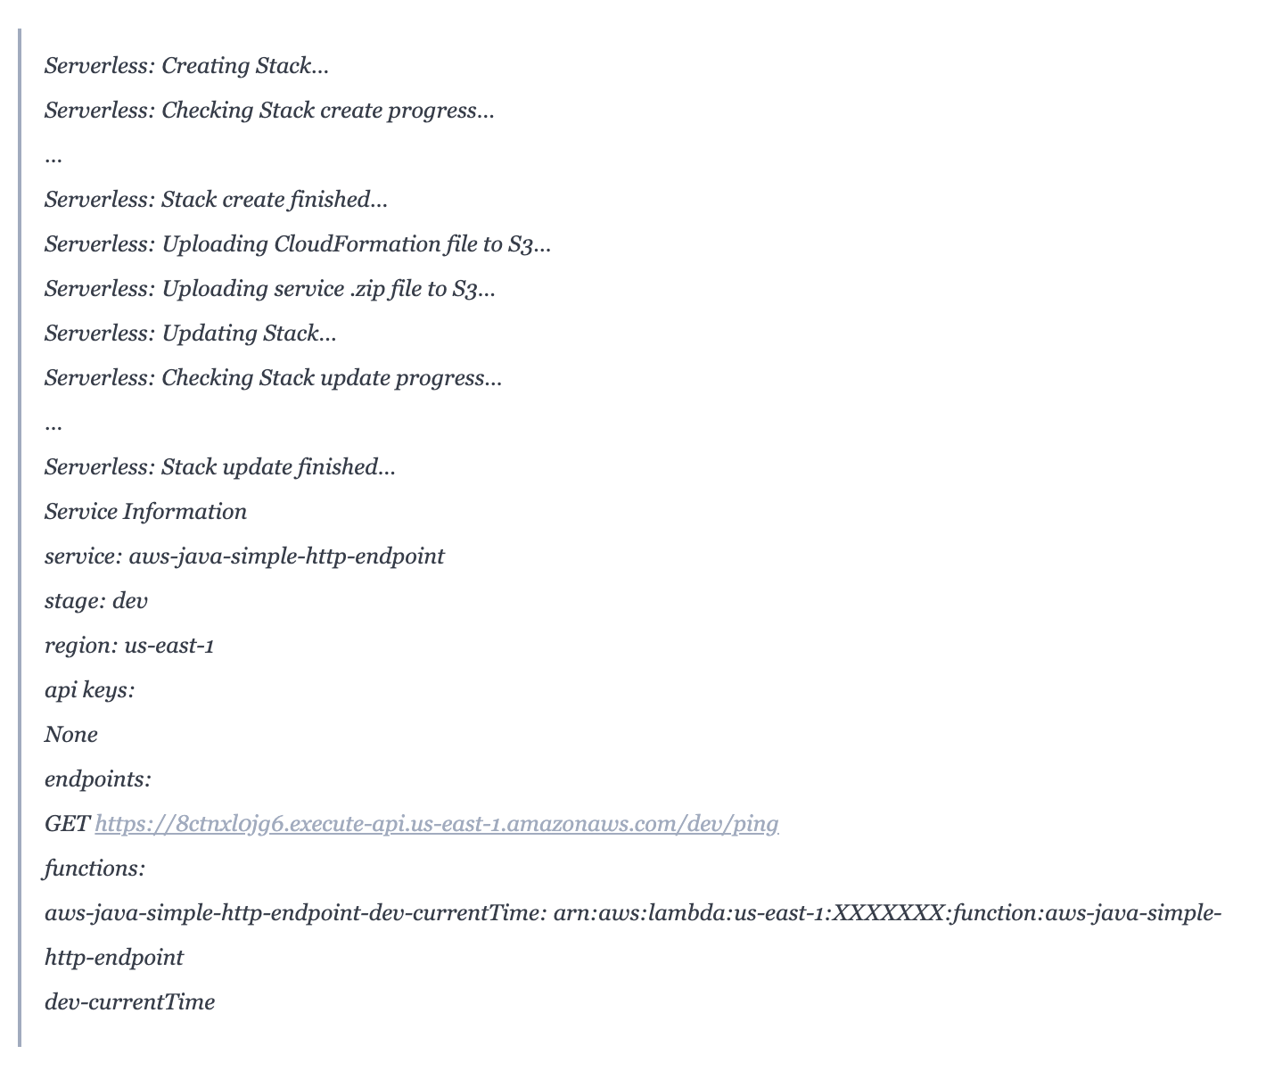

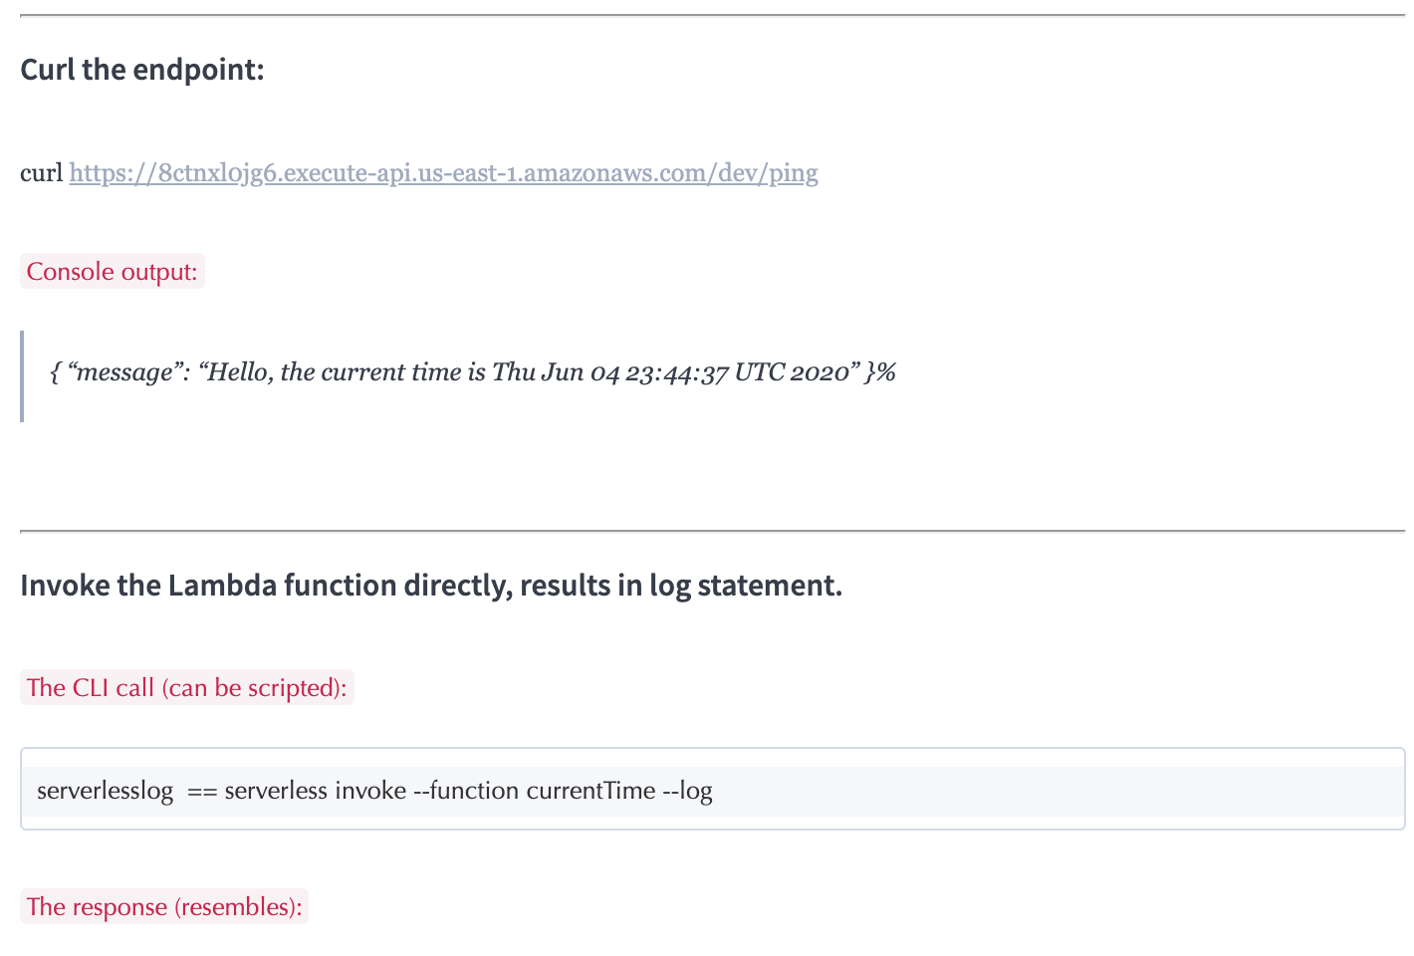

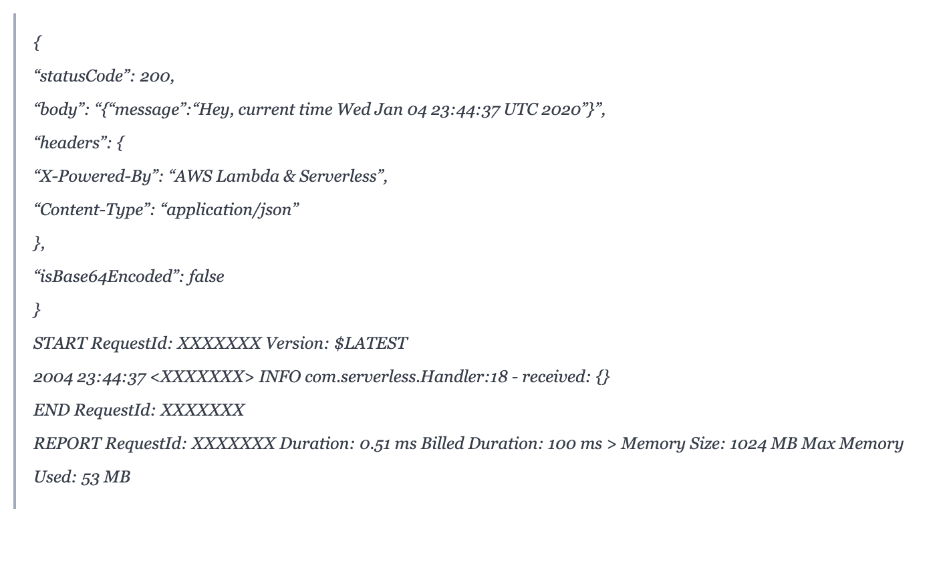

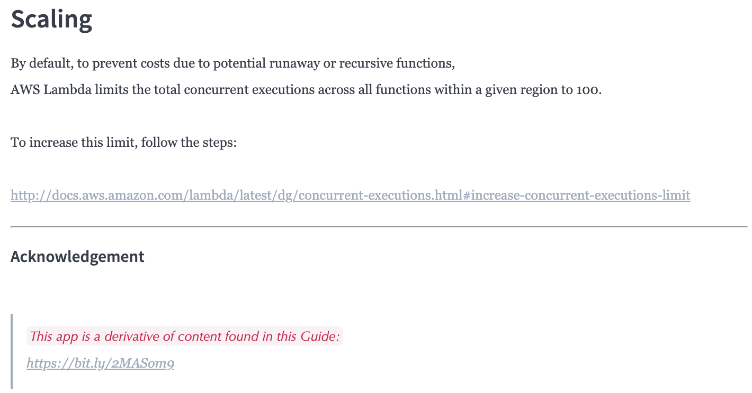

This is the end of the README.md File



*This app is a derivative of content found in this Guide:*

[*https://bit.ly/2MASom9*](https://bit.ly/2MASom9)